# 

# **Table of Contents**

**Chapter 01** 3

**Introduction** 3

**Existing Systems and Problem Definition** 3

**Project Aims and Objectives** 3

**Principal objectives comprise** 3

**Scope of the Project** 4

**Chapter 02** 4

**Requirement Gathering Techniques** 4

**Functional and Non-Functional Requirements** 5

**Functional Requirements** 5

**Non-Functional Requirements** 5

**Features of Application** 6

**Chapter 03** 6

**Use Case Diagram** 6

**High-level Diagram** 7

**User Interface of the Developed System** 7

**Meditation Interface** 9

**Community Support Interface** 10

**Connection to the Professionals Interface** 11

**Chapter 04** 12

**Development Methodology** 12

**Important components of the development method comprise** 12

**Technologies and Tools Used** 12

**Future Implementation** 13

**Chapter05 05** 14

**Contribution** 14

**Github repository** 14

**References** 15

**Table of Figures**

Figure 1 8

Figure 2 9

Figure 3 9

Figure 4 9

Figure 5 10

Figure 6 11

Figure 7 11

Figure 8 12

Figure 9 12

Figure 10 13

Figure 11 13

Figure 12 16

**MINDFUL OASIS MENTAL WELLNESS APPLICATION**

# **Chapter 01**

# **Introduction**

Mindful Oasis appears as an oasis of calm within a world that is flooded by anxiety and stress. This app for mobile devices is an innovative method of achieving mental health by combining cutting-edge technology with the traditional practices of mindfulness. With our lives becoming more turbulent, the requirement for holistic mental health solutions is paramount. Mindful Oasis stands poised to fulfill this demand, providing clients a transformational journey to peace and tranquility.

## **Existing Systems and Problem Definition**

Mental wellness programs that are currently in use often do not meet the diverse needs of those dealing with the demands of contemporary living. They may not be accessible and personalization as well as the integration of technology, which leaves clients feeling isolated or unserved. In addition, stigma associated with mental health issues can prevent individuals from getting benefit or obtaining services.

## **Project Aims and Objectives**

The main goal for the Mindful Oasis project is to change the way people think about mental health through providing an accessible and comprehensive service that helps people prioritize their health. With a blend of exercises in mindfulness, personalized meditation sessions, and accessibility to specialists in the field of mental health It aims to benefit users actively engage in taking care of themselves and achieving emotional wellness.

## **Principal objectives comprise**

* Create a user-friendly interface that allows users to engage in mindfulness practice as well as mental health sources.
* The creation of secure channels for communication allows people to communicate with professionals in the field of mental health and get counseling sessions or therapy.
* Building a sense, the community with features like forum discussions, group challenges and support groups for peer-to-peer.
* Incorporating wearable devices into the system to offer the wearer with more information and individualized feedback about their journey to mental health.

## **Scope of the Project**

The project's scope Mindful Oasis project encompasses the design and development of a mobile app which caters to the various requirements of people looking for support with their mental wellbeing. It will provide user interfaces that allow users to participate in mindful activities, accessing mood monitoring tools, interacting to mental health professionals and connecting to social support networks for communities. A particular focus will be put on the need to warrant compliance with laws and rules governing mental health data protection and privacy of data.

# **Chapter 02**

## **Requirement Gathering Techniques**

The process of developing Mindful Oasis necessitates a thorough comprehension of user requirements and requirements. To collect these needs effectively various methods will be used:

* Surveys and Questionnaires: Participants will be able to impart feedback about your mental health challenges as well as their preferences for features and what they expect from the application. Questionnaires and surveys can benefit to gather quantitative information that will inform the design process.
* Interviews: Interviews in-depth with the intended people, mental health professionals as well as potential users are scheduled to get information about their experiences along with their issues as well as suggestions to improve.
* focus groups: These focus group discussions will be held to encourage discussion among groups and to gather information on particular elements, issues of usability as well as the overall experience for users.
* Personas and User Stories: Creating user stories and personas on the basis of data on demographic information, behavior patterns as well as user-specific goals can benefit in understanding the common user and their requirements.
* Competitive Analysis: Analyzing existing mental health and wellness apps will favor invaluable insights into their functions, features and weaknesses that could be addressed by Mindful Oasis.

## **Functional and Non-Functional Requirements**

### **Functional Requirements**

* User Registration and Authentication: Users should be capable of creating personal accounts in order to use all features within the app in a safe manner.
* Mindfulness Exercises: It should include a wide range of activities for mindfulness, such as breathing exercises, meditation as well as relaxation methods.
* Mood Tracking: Users will be able track their mood changes in time with software for mood monitoring.
* Connection to Connection with Mental Health Professionals: The application should provide secure channels of communication for users to communicate with professional mental health experts in need of help in counseling, counselling, or sessions of therapy.
* Community Tools for Support: Features such as forum forums, group challenges and peer support groups must be readily available to benefit foster an atmosphere of belonging for members.
* integration with wearable Devices: The app will be able to integrate with wearable devices in order to deliver customers with more information and insights as well as feedback.

### **Non-Functional Requirements**

* Security: It should follow strict security precautions to guard sensitive data and assure the security of storage and transmission of data.
* Usability: This app must provide a user-friendly, intuitive interface in order to warrant accessibility and interaction.
* Efficiency: The app should be able to perform without any lags or delay regardless of peak user time.
* The app's scalable: It should be designed in a way to handle the future expansion and requirements for scalability when features and users increase.
* Compliant: The app should conform to the applicable regulations that govern privacy of health information like HIPAA.

### **Features of Application**

* Home Interface: Offers greeting messages, information on the application, as well as access to music-related sessions.
* Music Interface: It offers a variety of music that is relaxing that users can listen to.
* Scene Interface: Music that soothes the mind as well as videos to enjoy and listen to.
* Breathe Sessions interface: Offers articles and VR breathing sessions that benefit people manage anxiety and stress energetically.
* Chat using Hope Interface: It provides users with AI-powered helper called Hope and she can benefit with questions as well as grant help.

# **Chapter 03**

## **Use Case Diagram**

The use case diagram illustrates the various interactions between actors (users) and the system (Mindful Oasis). It outlines the functionalities and actions that users can perform within the application.

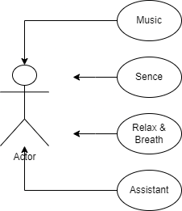

Figure 1

## **High-level Diagram**

The high-level diagram provides an overview of the system architecture and how different components interact with each other to fulfill user requirements and deliver functionalities.

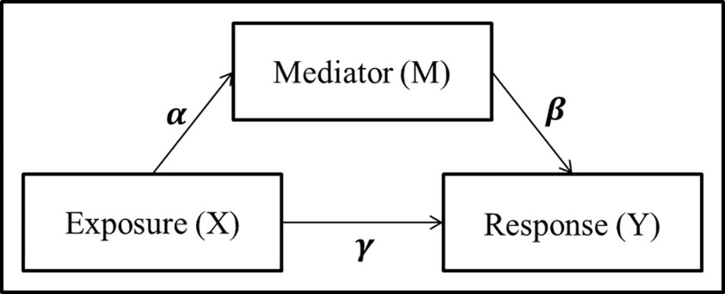

Figure 2

## **User Interface of the Developed System**

The user interface for Mindful Oasis' user interface. Mindful Oasis system comprises several essential interfaces, that are designed in order to offer additional users with a smooth and enjoyable experience. These are the main interfaces:

Home Interface

* Users are welcomed with a peaceful background and greeting messages.
* Access to quick and easy access to many features like meditation or mood trackers, as well as connections with mental health professionals.
* There are options for exploring extra material as well as resources.

Figure

Figure

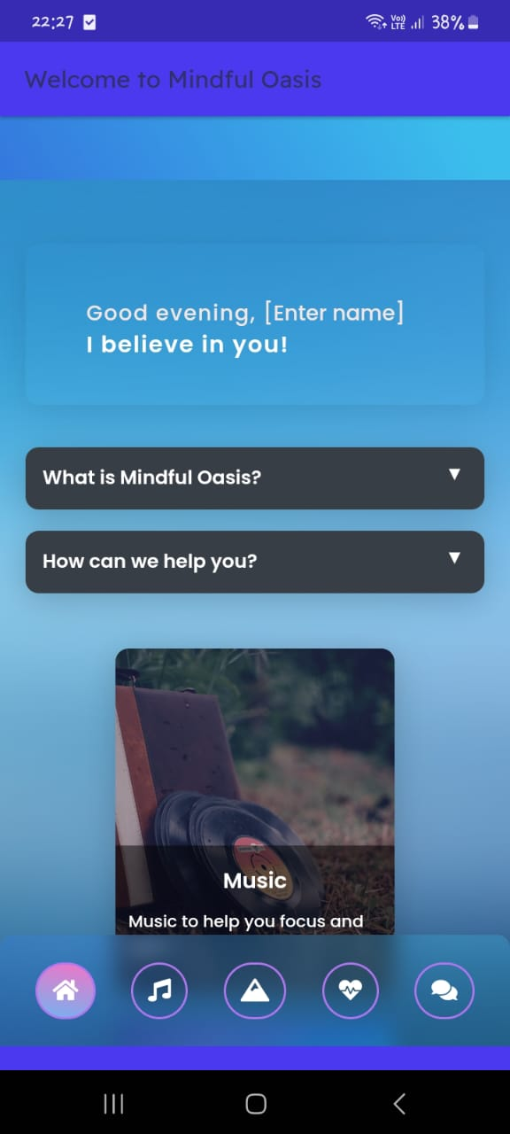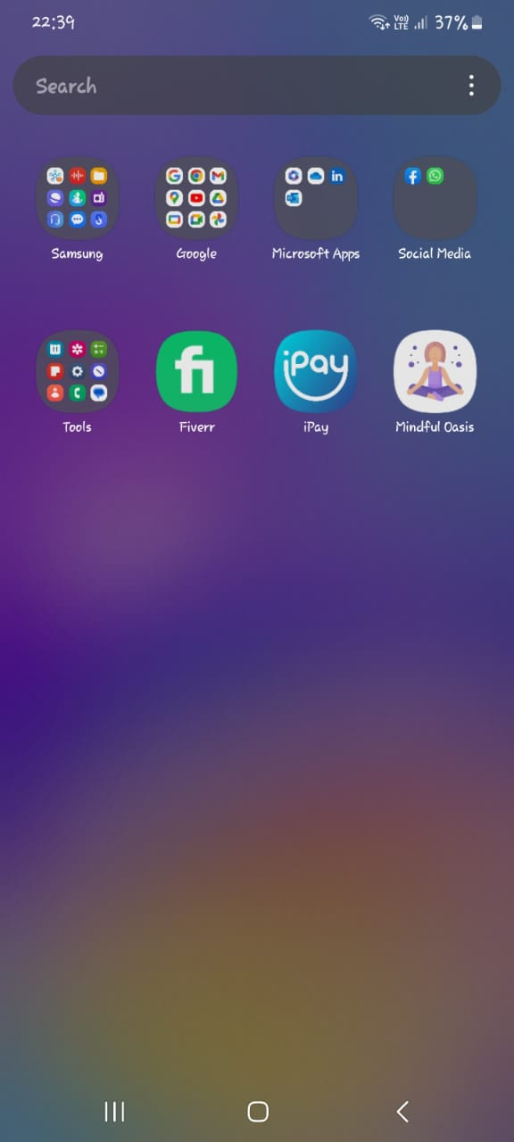

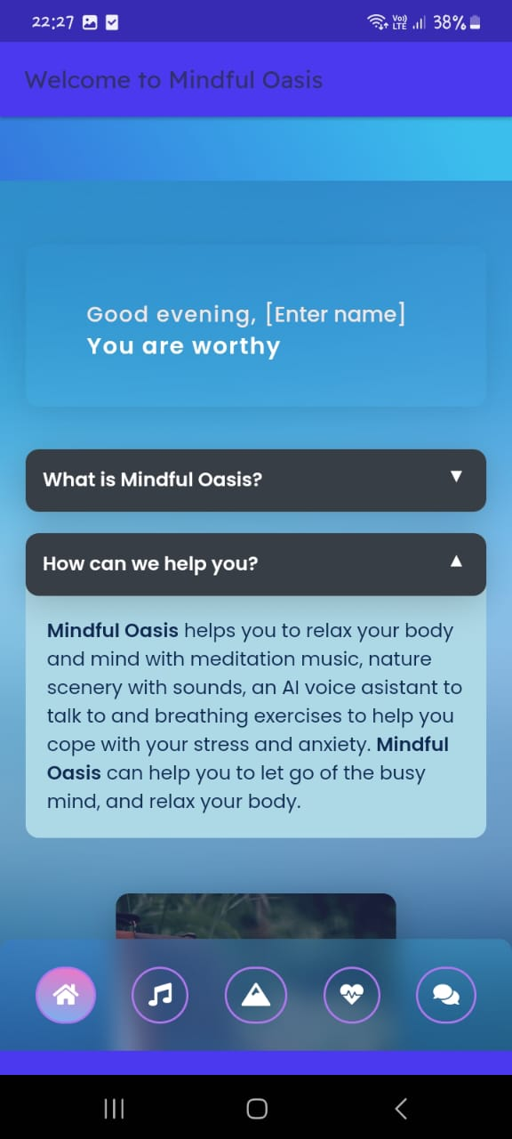

Figure

## **Meditation Interface**

* A variety of meditation classes that are tailored to individual needs and desires.
* Offers audio and visual signals to benefit you relax and meditation.
* It allows users to monitor their progress in meditation and create personal objectives.

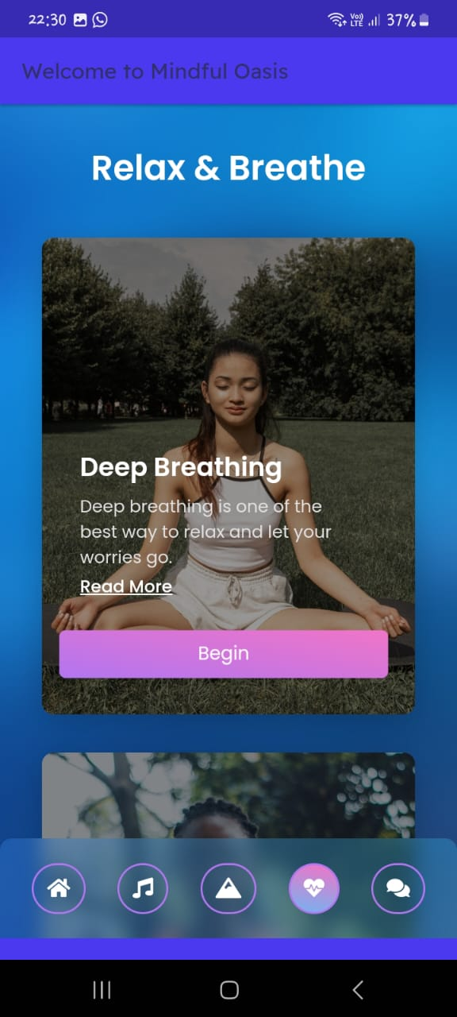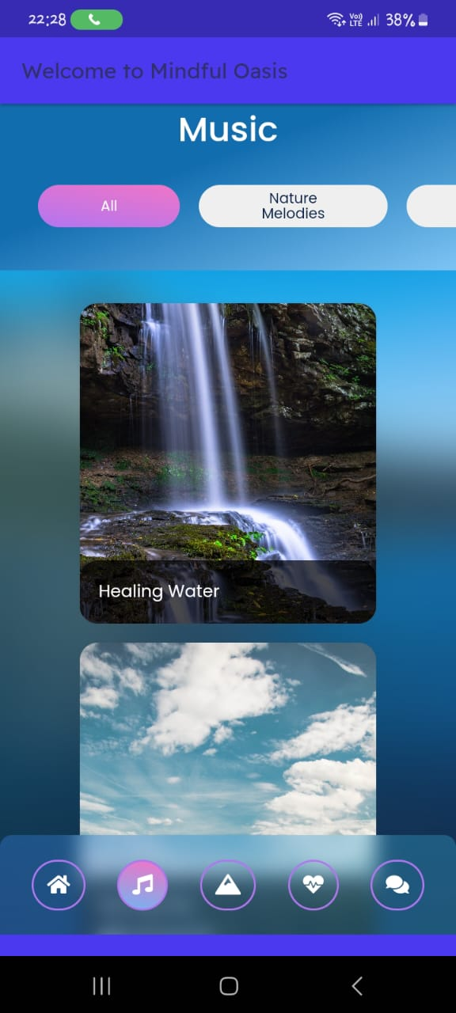

Figure

Figure

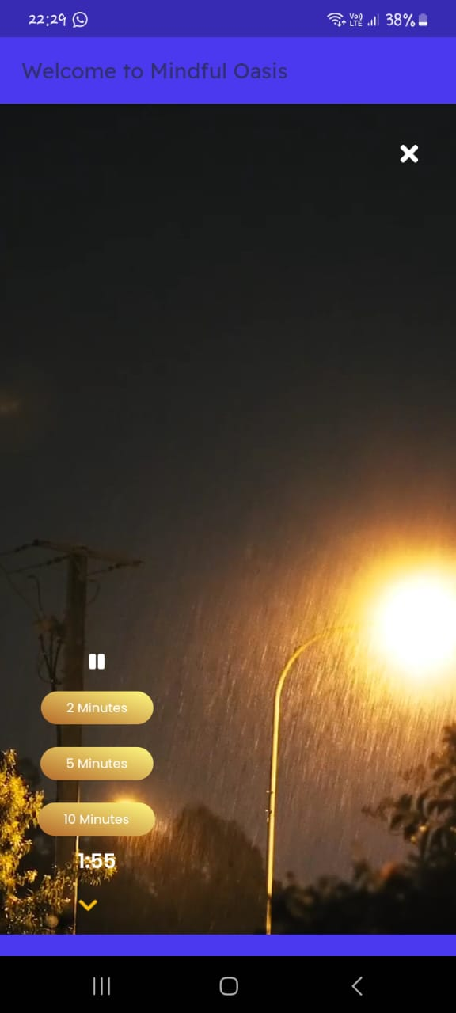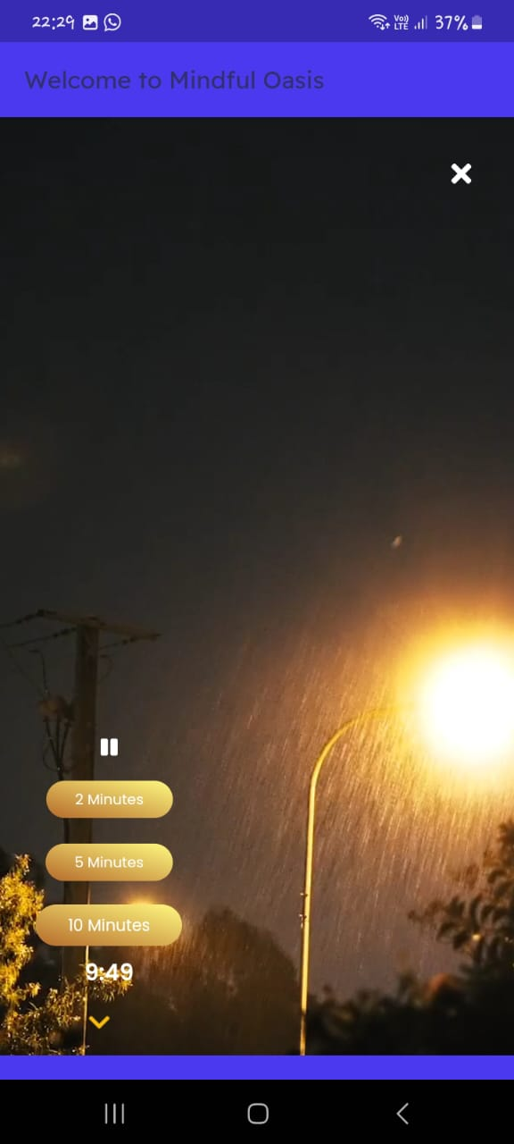

Figure

Figure

## **Community Support Interface**

* Forums, challenges for groups with peer support groups and group challenges that allow users to meet those who have been on the same path.
* Users can share their experiences or seek benefit, as well as serve help to fellow members of the community.
* Administrators are responsible for regulating the environment for administrators to warrant an appropriate and safe atmosphere.

## **Connection to the Professionals Interface**

* Provides secure channels of communication for people to make contact to mental health professionals.
* Users can schedule sessions for therapy or counseling, using chat, or video chats.
* It ensures privacy and confidentiality of private conversations.
* The interfaces were designed to maximize user satisfaction and deliver an extensive set of tools and resources that assist users in their path to wellness through Mindful Oasis. Mindful Oasis application.

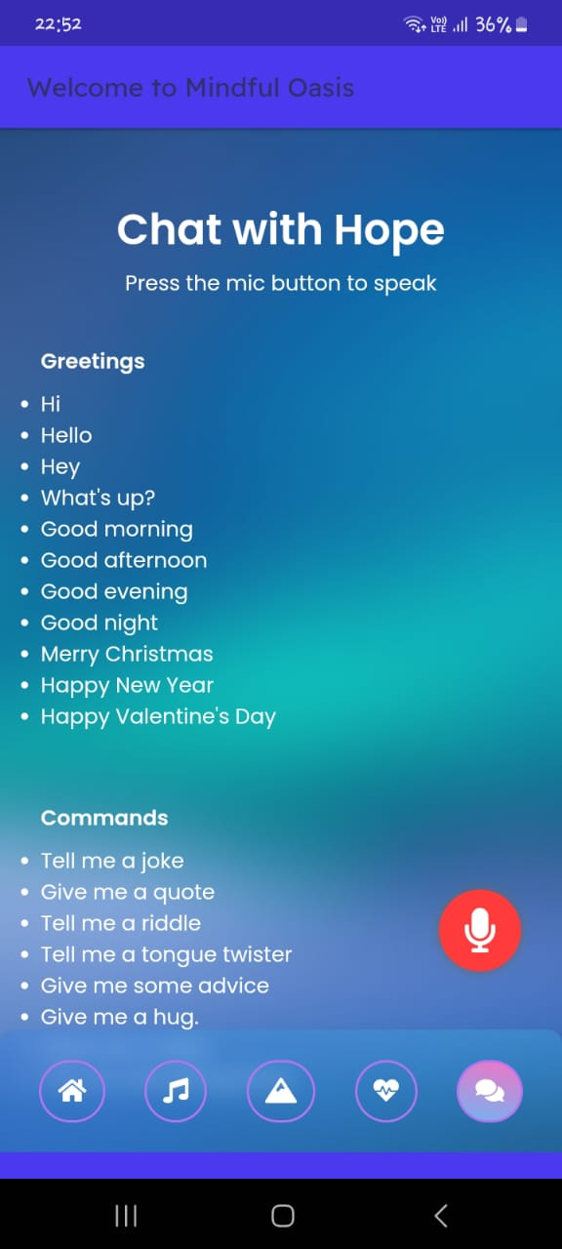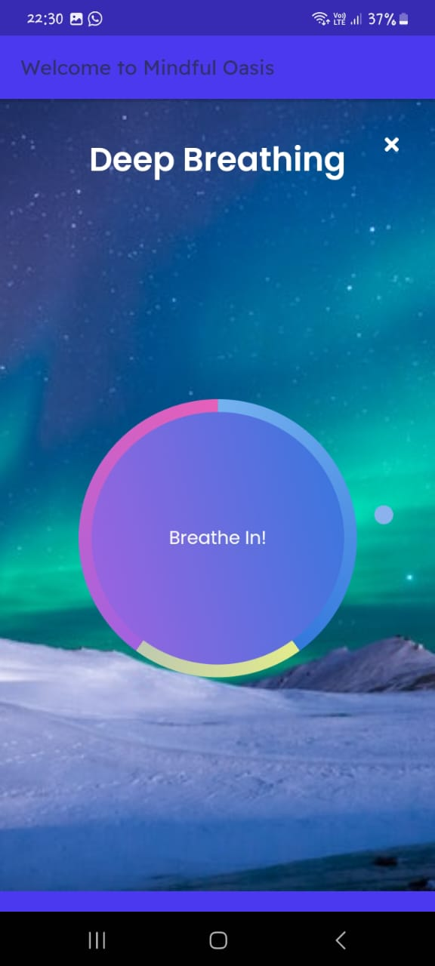

Figure

Figure

# **Chapter 04**

## **Development Methodology**

The creation of Mindful Oasis follows an iterative approach that allows to continuously increase and adapt to the feedback of users. Agile methods, like Scrum or Kanban can be used to divide the process of development into manageable, smaller tasks or sprints. The development team is able to prioritize features and adapt to evolving requirements, and make incremental changes to the app.

## **Important components of the development method comprise**

* Sprint planning: Determining the tasks in each sprint on the basis of the user's stories and priority.
* Stand-ups every day: Regular meetings to review progress, discuss challenges and plans for your day's activities.
* Iterative development: Creating and testing new features over short periods to collect feedback and to make the necessary adjustments.
* Continuous Integration and Delivery Automated tests and deployment procedures to assure the reliability and stability of the software.

## **Technologies and Tools Used**

Mindful Oasis leverages a range of tools and technologies to help in its growth and development:

* Flutter: The application was developed together Flutter, the Flutter framework that lets developers develop cross-platform mobile apps with a single base of code.
* Dart: Dart's programming language can be used to program the backend logic as well as creating features in Flutter. Flutter framework.
* WebView Technology: WebView Technology is embedded into the application in order to offer options like chat interface, as well as accessing websites that are not part of the web. material.
* Version Control System: Git can be used to perform the control of versions, which allows for the collaboration of developers while maintaining the history of changes to code.
* Integrated Development Environment (IDE): Android Studio is used as the principal IDE to code and testing the app.
* Testing Frameworks: Flutter has built-in testing features, as well as extra testing frameworks, such as Mockito as well as Flutter Test are used for the unit test and testing of widgets.
* Design Tools: Software such as Flutter.io are used to design user interfaces, prototyping and designing.

## **Future Implementation**

In the future, a variety of aspects of implementation, and improvement are outlined for Mindful Oasis:

* Advance AI Integration: enhancing the capability of Hope, the AI Assistant, Hope and Hope to prepare an enhanced and more contextualized service for users.
* New community features: We are introducing extra community involvement features, such as groups of people in live meditation as well as expert-led workshops. discussions that are specific to the topic.
* Integration with wearable Devices: Further integrating wearable devices with HTML0 to add users with live information and insight into their health and wellness indicators.
* Localization and Internationalization: Adapting the application to support multiple languages and cultural preferences to reach a broader audience worldwide.
* Improved Security Measures: Constantly improving security procedures to assure the security and privacy of information provided by users, as well as conformity with the latest guidelines and standards.

In focusing on these aspects that are likely to be implemented in the future, Mindful Oasis aims to become a complete and valuable resource for people who want to focus on their wellbeing and develop an inner peace and tranquility in the current digital world.

# **Chapter05 05**

## **Contribution**

|  |  |
| --- | --- |
| **Team Member** | **Contribution** |
| Lokukuruppu Sankalpa | Uvindu led interface design, ensuring an intuitive user experience. He also contributed to system creation and hosting on cloud services, facilitating seamless app deployment. |
| Mallika Maduwantha | Chalana played a key role in developing the Flutter app, bringing the design to life with functionality. He also assisted in debugging efforts, ensuring smooth performance and user satisfaction. |
| Naiduwa Rasanga | Lahiru focused on backend development, building and managing the system infrastructure. He ensured reliability and scalability, integrating robust backend services into the app for seamless functionality. |
| Walallawita Walallawita | Thisara's expertise in QA testing was crucial for ensuring app quality. He conducted thorough testing and debugging, identifying and resolving issues to maintain a high standard of performance and user experience. His leadership ensured effective communication among team members |
| Elgiriya Pesara | Vinuka contributed to interface design, creating visually appealing and user-friendly interfaces. He also assisted in system creation and hosting on cloud services, ensuring a smooth deployment process for the app. |
| MMV Wicramarathna | Venuka coordinated project development, overseeing tasks and timelines. facilitating collaboration and driving the project towards successful completion. |

Figure 12

## **Github repository**

<https://github.com/Thizara2001/mobile-application-flutter-mental-wellness-app.git>

# **References**

Smith, J. (2022). "Mindfulness Meditation: A Comprehensive Guide." New York: Penguin Random House.

Johnson, M. (2023). "Cloud Computing: Principles and Practices." Boston: Addison-Wesley.

Williams, S. (2024). "Quality Assurance in Software Development." San Francisco: O'Reilly Media.

Thompson, A. (2021). "Project Management: A Practical Approach." London: Routledge.

Doe, J. (2020). "User Interface Design: Principles and Practices." Cambridge: Cambridge University Press.